Navigation Drawer + Tab + ViewPager



Mô tả:

MaiActivity chứa NavigationDrawer.

Trên navigation chọn Inbox sẽ load TabFragment. Trong TabFragment sẽ có ViewPager với 3 Fragment là PrimaryFragment, SocialFragment và DraftsFragment.

Trên navigation chọn Send thì sẽ qua SendFragment.

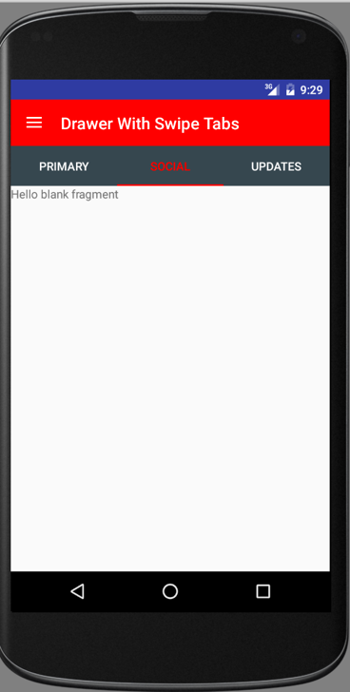 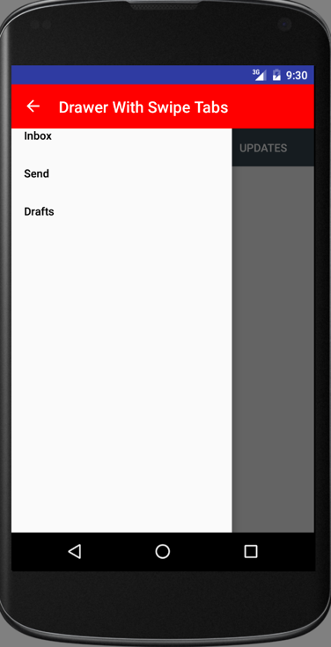 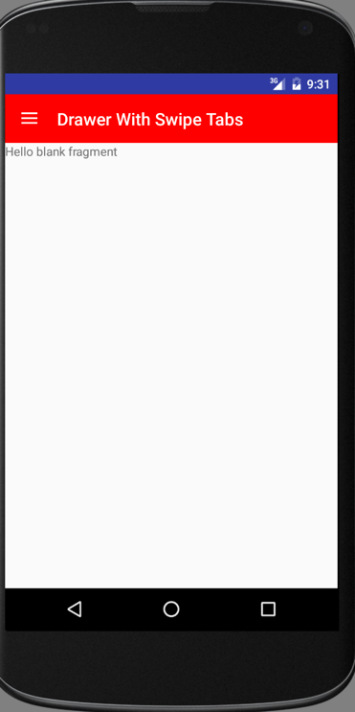

1. Tạo project, nhúng thư viện

compile **'com.android.support:appcompat-v7:23.4.0'**compile **'com.android.support:design:23.0.1'**

1. Tạo thư mục mới tên “menu” trong thư mục res. Trong thư mục menu tạo file tên drawermenu.xml

*<?***xml version="1.0" encoding="utf-8"***?>*<**menu xmlns:android="http://schemas.android.com/apk/res/android"**>  
 <**item android:title="Inbox"  
 android:id="@+id/inbox"** />  
 <**item android:title="Send"  
 android:id="@+id/send"** />  
 <**item android:title="Drafts"  
 android:id="@+id/drafts"** />  
</**menu**>

1. File xml chính MainActivity.xml

*<?***xml version="1.0" encoding="utf-8"***?>*<**LinearLayout  
 xmlns:android="http://schemas.android.com/apk/res/android"  
 xmlns:app="http://schemas.android.com/apk/res-auto"  
 android:layout_width="match_parent"  
 android:layout_height="match_parent"  
 android:fitsSystemWindows="true"  
 android:orientation="vertical"**>  
  
 <**android.support.v7.widget.Toolbar  
 xmlns:android="http://schemas.android.com/apk/res/android"  
 android:layout_width="match_parent"  
 android:layout_height="wrap_content"  
 android:background="#ff0000"  
 android:id="@+id/toolbar"  
 android:theme="@style/ThemeOverlay.AppCompat.Dark.ActionBar"  
 app:title="Drawer With Swipe Tabs"** />  
  
 <**android.support.v4.widget.DrawerLayout  
 android:layout_height="match_parent"  
 android:layout_width="match_parent"  
 android:id="@+id/drawerLayout"** >  
  
 <**FrameLayout  
 android:orientation="vertical"  
 android:layout_width="match_parent"  
 android:layout_height="match_parent"  
 android:id="@+id/containerView"**>  
 </**FrameLayout**>  
   
 <**android.support.design.widget.NavigationView  
 xmlns:android="http://schemas.android.com/apk/res/android"  
 xmlns:app="http://schemas.android.com/apk/res-auto"  
 android:layout_width="wrap_content"  
 android:layout_height="match_parent"  
 android:layout_gravity="start"  
 android:id="@+id/shitstuff"  
 app:itemTextColor="#000000"  
 app:menu="@menu/drawermenu"  
 android:layout_marginTop="-24dp"** />  
 </**android.support.v4.widget.DrawerLayout**>  
  
</**LinearLayout**>

1. Tạo một file tên tab_layout.xml

*<?***xml version="1.0" encoding="utf-8"***?>*<**LinearLayout  
 xmlns:android="http://schemas.android.com/apk/res/android"  
 xmlns:app="http://schemas.android.com/apk/res-auto"  
 android:layout_width="match_parent"  
 android:orientation="vertical"  
 android:layout_height="wrap_content"**>  
   
 <**android.support.design.widget.TabLayout  
 android:id="@+id/tabs"  
 app:tabGravity="fill"  
 app:tabMode="fixed"  
 android:background="@color/material_blue_grey_800"  
 app:tabIndicatorColor="#ff0000"  
 app:tabSelectedTextColor="#ff0000"  
 app:tabTextColor="#ffffff"  
 android:layout_width="match_parent"  
 android:layout_height="wrap_content"**>  
 </**android.support.design.widget.TabLayout**>  
  
 <**android.support.v4.view.ViewPager  
 android:id="@+id/viewpager"  
 android:layout_width="match_parent"  
 android:layout_height="match_parent"**>  
 </**android.support.v4.view.ViewPager**>  
   
</**LinearLayout**>

1. Tạo ra 3 Fragment mới tên PrimaryFragment , SocialFragment , SocialFragment cho viewpager và tạo thêm 3 Fragment cho DrawerLayout tên SendFragment, DraftsFragment.
2. Tạo một file java mới tên TabFragment.java kế thừ từ Fragment, khai báo các biến toàn cục

**public static** TabLayout *tabLayout*;  
**public static** ViewPager *viewPager*;  
**public static int** *int_items* = 3 ;

1. Viết tiếp hàm onCreateView như sau:

@Override  
**public** View onCreateView(LayoutInflater inflater, ViewGroup container, Bundle savedInstanceState) {  
 */* gan layout va anh xa */* View x=inflater.inflate(R.layout.***tab_layout***,**null**);  
 *tabLayout*=(TabLayout)x.findViewById(R.id.***tabs***);  
 *viewPager*=(ViewPager)x.findViewById(R.id.***viewpager***);  
  
 */* Set adapter cho viewpager */  
 viewPager*.setAdapter(**new** MyAdapter(getChildFragmentManager()));  
  
 */* can cai nay chu khong se bi loi */  
 tabLayout*.post(**new** Runnable() {  
 @Override  
 **public void** run() {  
 *tabLayout*.setupWithViewPager(*viewPager*);  
 }  
 });  
 **return** x;  
}

1. Viết một class nội trong class TabFragment có nội dung như sau:

**class** MyAdapter **extends** FragmentPagerAdapter {  
  
 **public** MyAdapter(FragmentManager fm) {  
 **super**(fm);  
 }  
 @Override  
 **public** Fragment getItem(**int** position)  
 {  
 **switch** (position){  
 **case** 0 : **return new** PrimaryFragment();  
 **case** 1 : **return new** SocialFragment();  
 **case** 2 : **return new** UpdatesFragment();  
 }  
 **return null**;  
 }  
 @Override  
 **public int** getCount() {  
 **return** *int_items*;  
 }  
 @Override  
 **public** CharSequence getPageTitle(**int** position) {  
  
 **switch** (position){  
 **case** 0 :  
 **return "Primary"**;  
 **case** 1 :  
 **return "Social"**;  
 **case** 2 :  
 **return "Updates"**;  
 }  
 **return null**;  
 }  
}

1. Mở file java chính “MainActivity.java” khai báo các biến toàn cục

DrawerLayout **mDrawerLayout**;  
NavigationView **mNavigationView**;  
FragmentManager **mFragmentManager**;  
FragmentTransaction **mFragmentTransaction**;

1. Trong hàm onCreate ánh xạ

**mDrawerLayout** = (DrawerLayout)findViewById(R.id.***drawerLayout***);  
**mNavigationView** = (NavigationView)findViewById(R.id.***shitstuff***);

1. Tiếp tục viết trong onCreate

**mFragmentManager** = getSupportFragmentManager();  
**mFragmentTransaction** = **mFragmentManager**.beginTransaction();  
**mFragmentTransaction**.replace(R.id.***containerView***,**new** TabFragment()).commit();

1. Viết tiếp để gắn fragment cho DrawerLayout

**mNavigationView**.setNavigationItemSelectedListener(**new** NavigationView.OnNavigationItemSelectedListener() {  
 @Override  
 **public boolean** onNavigationItemSelected(MenuItem menuItem) {  
 **mDrawerLayout**.closeDrawers();  
  
 **if** (menuItem.getItemId() == R.id.***inbox***) {  
 FragmentTransaction xfragmentTransaction = **mFragmentManager**.beginTransaction();  
 xfragmentTransaction.replace(R.id.***containerView***,**new** TabFragment()).commit();  
 }  
 **if** (menuItem.getItemId() == R.id.***send***) {  
 FragmentTransaction fragmentTransaction = **mFragmentManager**.beginTransaction();  
 fragmentTransaction.replace(R.id.***containerView***,**new** SendFragment()).commit();  
 }  
 **if** (menuItem.getItemId() == R.id.***drafts***) {  
 FragmentTransaction xfragmentTransaction = **mFragmentManager**.beginTransaction();  
 xfragmentTransaction.replace(R.id.***containerView***,**new** DraftsFragment()).commit();  
 }  
 **return false**;  
 }  
});

1. Viết tiếp để gắn drawer toogle như sau:

android.support.v7.widget.Toolbar toolbar = (android.support.v7.widget.Toolbar) findViewById(R.id.***toolbar***);  
ActionBarDrawerToggle mDrawerToggle = **new** ActionBarDrawerToggle(**this**,mDrawerLayout, toolbar,R.string.***app_name***,  
 R.string.***app_name***);  
mDrawerLayout.setDrawerListener(mDrawerToggle);  
mDrawerToggle.syncState();

1. Chạy ct, còn bị đính 1 actionbar ở trên. Mở file styles.xml lên sửa style của AppTheme từ DarkActionBar thành NoActionBar.

<**style name="AppTheme" parent="Theme.AppCompat.Light.NoActionBar"**>

1. Chạy ct, đẹp rồi đó.